# Worksheet 16: Dynamic Array Stack

**In Preparation**: Read Chapter 6 to learn more about the Stack data type. If you have not done so already, you should complete worksheets 14 and 15 to learn about the basic features of the dynamic array.

Conceptual Stack Operations

void push (TYPE newValue)

TYPE top ()

void pop ()

Boolean isEmpty ()

In Chapter 6 you read about the Stack data abstraction. A stack maintains values in order based on their time of insertion. When a value is removed from the stack it is the value that has been most recently added to the stack. The abstract definitions of the stack operations are shown at right.

As you learned in Worksheet 14, a positive feature of the array is that it provides random access to values. Elements are accessed using an index, and the time it takes to access any one element is no different from the time it takes to access another. However, a fundamental problem of the simple array is that the size must be specified at the time the array is created. Often the size cannot be easily predicted; for example if the array is being filled with values being read from a file. A solution to this problem is to use a *partially filled array*; an array that is purposely larger than necessary. A separate variable keeps track of the number of elements in the array that have been filled.

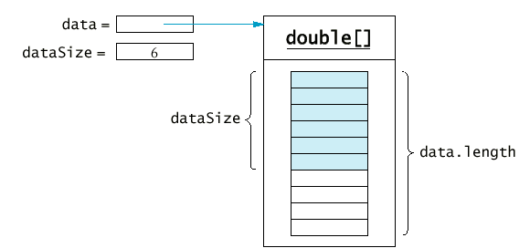

The *dynamic array* data type uses this approach. The array of values is encapsulated within a structure boundary, as is the current *size* of the collection. The size represents the number of elements in the array currently in use. The size is different from the *capacity*, which is the actual size of the array. Because the array is referenced by a pointer, an allocation routine must be called to set the initial size and create the initial memory area. A separate destroy routine frees this memory. You wrote these earlier in Worksheet 14.

The function dynArrayAdd (struct DynArr * da, TYPE e) adds a new value to end of a dynamic array. Recall from Worksheet 14 that this function could potentially increase the size of the internal buffer if there was insufficient space for the new value. This is shown in the following two pictures. In the first picture there is space for the new value, so no reallocation is needed. In the second picture there is no longer enough space, and so a new buffer is created, the elements are copied from the old buffer to the new, and the value is then inserted into the new buffer. You wrote the function dynArrayAdd in worksheet 14. Do you remember the worst-case algorithmic execution time for this function?

# Your task in this worksheet is to write the code for the Stack functions push, pop, top and isEmpty. These functions should use a dynamic array (passed as an argument) for the storage area. Use an assertion to check that the stack has at least one element when the functions top or pop are called. Your job will be greatly simplified by making use of the following functions, which you developed in previous lessons:

struct DynArr {

TYPE * data;

int size;

int capacity;

};

/* initialize a dynamic array structure with given capacity */

void dynArrayInit (struct DynArr * da, int initialCapacity);

/* internal method to double the capacity of a dynamic array */

void _dynArraySetCapacity (struct DynArr * da);

/* release dynamically allocated memory for the dynamic array */

void dynArrayFree (struct DynArr * da);

/* return number of elements stored in dynamic array */

int dynArraysize (struct DynArr * da);

/* add a value to the end of a dynamically array */

void dynArrayAdd (struct DynArr * da, TYPE e);

/* remove the value stored at position in the dynamic array */

void dynArrayRemoveAt (struct DynArr * da, int position);

/* retrieve element at a given position */

TYPE dynArrayGet (struct DynArr * da, int position);

/* store element at a given position */

void dynArrayPut (struct DynArr * da, int position, TYPE value);

# define TYPE int

struct DynArr {

TYPE * data;

int size;

int capacity;

};

void dynArrayPush (struct DynArr * da, TYPE e) {

assert(da != 0);

if(da->size == da->capacity)

_setCapacityDynArr(da, da->capacity*2);

da->data[da->size] = e;

da->size++;

}

TYPE dynArrayTop (struct DynArr * da) {

assert(da != 0 && da->size > 0);

return da->[da-size-1];

}

void dynArrayPop (struct DynArr * da) {

assert(da != 0 && da->size > 0);

da->size--;

}

int dynArrayIsEmpty (struct DynArr * da) {

assert(da != 0);

if(da->size > 0)

return 0;

return 1;

}

### Questions

1. What is the algorithmic execution time for the operations **pop** and **top**?

O(1) -- simply return the top element or reduce the size of the stack.

2. What is the algorithmic execution time for the operation **push,** assuming there is sufficient capacity for the new elements?

O(1) -- since we're only adding an element at `size`.

3. What is the algorithmic execution time for the internal method **_dynArraySetCapacity**?

O(n) -- since we need to copy the elements from the old array to the new array. The number of elements in the old array will determine the execution time of the operation.

4. Using as a basis your answer to 3, what is the algorithmic execution time for the operation **push** assuming that a new array must be created.

O(n) -- since we need to copy the array and allocate a new capciaty. The additinal step to add an element to the stack is negligible.